1. **How to make a directory**

**Command used**- mkdir

It is used to create directory

**Example -** mkdir shubham (here shubham is directory’s name)

shubham@shubham-IdeaPad-Gaming-3-15IMH05:~$ mkdir shubham

shubham@shubham-IdeaPad-Gaming-3-15IMH05:~$ cd shubham

shubham@shubham-IdeaPad-Gaming-3-15IMH05:~/shubham$



1. **How to remove a directory**

**Command used -** rmdir

It is used to remove or delete directory

**Example -** rmdir shubham (here shubham is directory’s name)

shubham@shubham-IdeaPad-Gaming-3-15IMH05:~$ rmdir shubham

shubham@shubham-IdeaPad-Gaming-3-15IMH05:~$ cd shubham

bash: cd: shubham: No such file or directory



1. **How to make a copy of a file**

**Command used -** cp source_file destination_file

It is used to copy the content of one file to another file

**Example -** cp file.txt file2.txt (here file.txt and file2.txt are names of the files)

shubham@shubham-IdeaPad-Gaming-3-15IMH05:~$ mkdir test

shubham@shubham-IdeaPad-Gaming-3-15IMH05:~$ cd test

shubham@shubham-IdeaPad-Gaming-3-15IMH05:~/test$ touch file.txt

shubham@shubham-IdeaPad-Gaming-3-15IMH05:~/test$ nano file.txt

shubham@shubham-IdeaPad-Gaming-3-15IMH05:~/test$ touch file2.txt

shubham@shubham-IdeaPad-Gaming-3-15IMH05:~/test$ cat file.txt

this file is copied

shubham@shubham-IdeaPad-Gaming-3-15IMH05:~/test$ cp file.txt file2.txt

shubham@shubham-IdeaPad-Gaming-3-15IMH05:~/test$ cat file.txt

this file is copied

shubham@shubham-IdeaPad-Gaming-3-15IMH05:~/test$ cat file2.txt

this file is copied

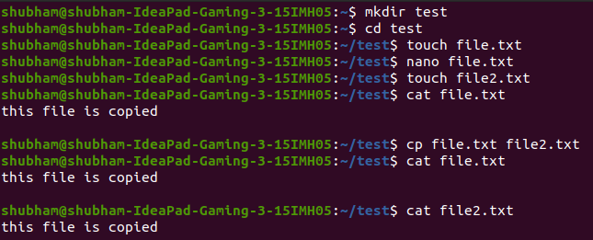

1. **How to move or rename a file**

**Command used-** mv

This command is used to move or rename file.

shubham@shubham-IdeaPad-Gaming-3-15IMH05:~/dir1$ mv myfile1.txt dir2

shubham@shubham-IdeaPad-Gaming-3-15IMH05:~/dir1$ ls

Dir2



1. **How to create an empty file**

**Command used -** touch

This command is used to create an empty file.

**Example-** touch file1.txt

shubham@shubham-IdeaPad-Gaming-3-15IMH05:~$ mkdir dir1

shubham@shubham-IdeaPad-Gaming-3-15IMH05:~$ cd dir1

shubham@shubham-IdeaPad-Gaming-3-15IMH05:~/dir1$ touch file1.txt

shubham@shubham-IdeaPad-Gaming-3-15IMH05:~/dir1$ ls

file1.txt

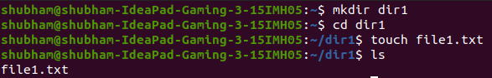

1. **To remove multiple files with a single command**

**Command used -** rm

**Example-** rm file1 file2 file3 file4 file5

shubham@shubham-IdeaPad-Gaming-3-15IMH05:~/dir1$ ls

file1 file2 file3 file4 file5

shubham@shubham-IdeaPad-Gaming-3-15IMH05:~/dir1$ rm file1 file2 file3 file4 file5

shubham@shubham-IdeaPad-Gaming-3-15IMH05:~/dir1$ ls

shubham@shubham-IdeaPad-Gaming-3-15IMH05:~/dir1$

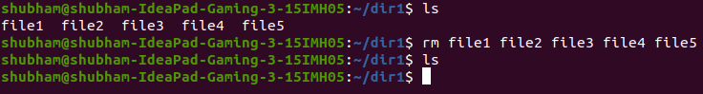

1. **To remove content from the folder without removing folder**

**Command used-** rm -r *

This command removes all files and subdirectories within the current directory.

**Example**

shubham@shubham-IdeaPad-Gaming-3-15IMH05:~/dir1$ ls

A C E G I K M O Q S U W Y

B D F H J L N P R T V X Z

shubham@shubham-IdeaPad-Gaming-3-15IMH05:~/dir1$ rm -r *

shubham@shubham-IdeaPad-Gaming-3-15IMH05:~/dir1$ ls

shubham@shubham-IdeaPad-Gaming-3-15IMH05:~/dir1$ ^C

shubham@shubham-IdeaPad-Gaming-3-15IMH05:~/dir1$

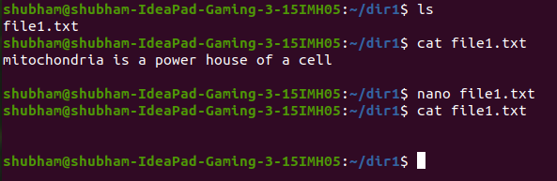

1. **To create multiple folder(a-z) with a single command**

**Command used -** mkdir{a..b}

This command is used to create files named from A to Z in one go.

**Example -**  mkdir{a..b}

shubham@shubham-IdeaPad-Gaming-3-15IMH05:~/dir1$ mkdir {a..z}

shubham@shubham-IdeaPad-Gaming-3-15IMH05:~/dir1$ ls

a b c d e f g h i j k l m n o p q r s t u v w x y z

